Selenium GRID ::

How to create new Hub

java -jar C:\SAMA-MPP\mpprepository\selenium-server-standalone-3.141.59.jar -role hub

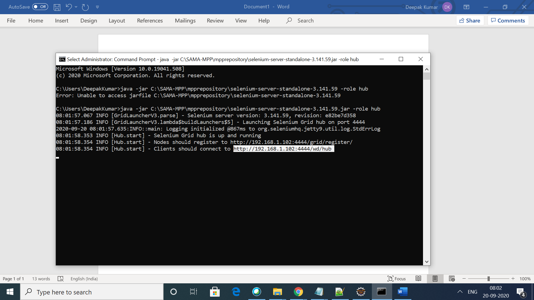

How to check status of grid .

Please enter below command in the browser

<http://localhost:4444/grid/console>

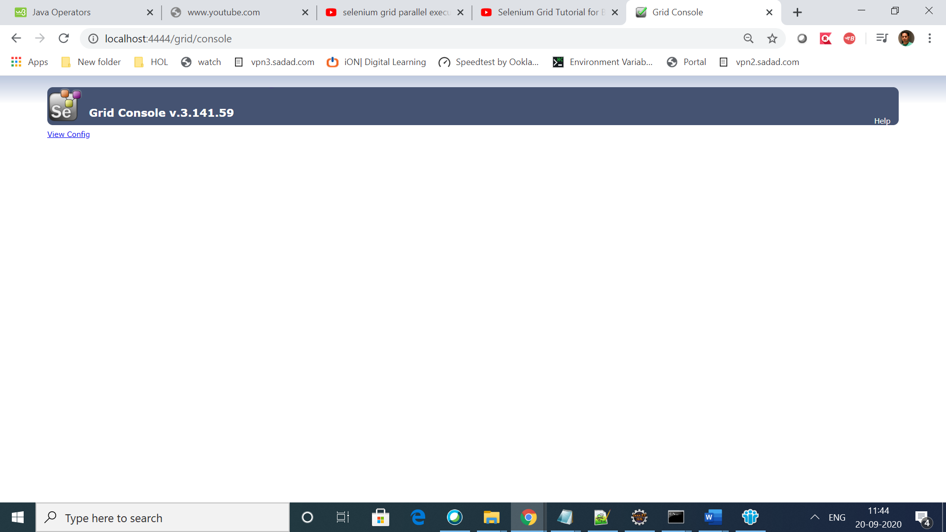

############### Add Nodes to the hub #######################

08:01:58.353 INFO [Hub.start] - Selenium Grid hub is up and running

08:01:58.354 INFO [Hub.start] - Nodes should register to **http://192.168.1.102:4444/grid/register/**

08:01:58.354 INFO [Hub.start] - Clients should connect to <http://192.168.1.102:4444/wd/hub>

**Command to add new node to above created hub::** java -jar C:\SAMA-MPP\mpprepository\selenium-server-standalone-3.141.59.jar -role node -hub http://192.168.1.102:4444/grid/register

